Micromouse Starter Robot Assembly Instructions
Author | Binara Wasala
Last Revision | 12/07/2026
Revision | A

Parts:
Part | Qty.
3.7V LiPo Battery | 1
43mm Rubber Wheel | 2
Caster Ball | 1
IR Sensor | 3
M3x8mm Hex Socket Bolt | 15
Micro Motor 60RPM | 2
MM Base Plate | 1
MM Caster Ball Extension | 1
MM Motor Clamp | 2
MM PCB | 1
MM Top Plate | 1


 | Micromouse Starter Robot | Step: | 1
Parts Required:
- 1 x MM Base Plate
- 1 x MM Caster Ball Extension
- 2 x M3x8mm Hex Socket Bolt

Instructions:
- Fasten the MM Caster Ball Extension (B) to the MM Base Plate (A) using M3x8mm bolts (C).
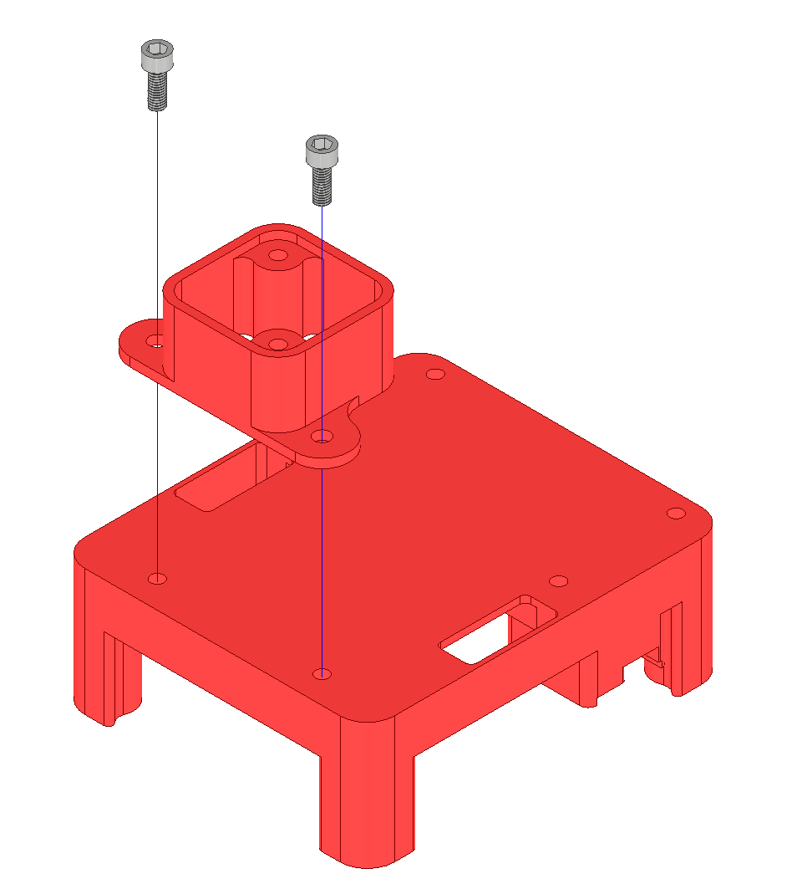
2 x C
B
A
 | Micromouse Starter Robot | Step: | 2
Parts Required:
- 1 x MM Base Plate with components fitted (where step 1 of this procedure has been completed)
- 1 x Caster Ball
- 2 x M3x8mm Hex Socket Bolt

Instructions:
- Fasten the Caster Ball (B) to the MM Base Plate (A) using M3x8mm bolts (C).
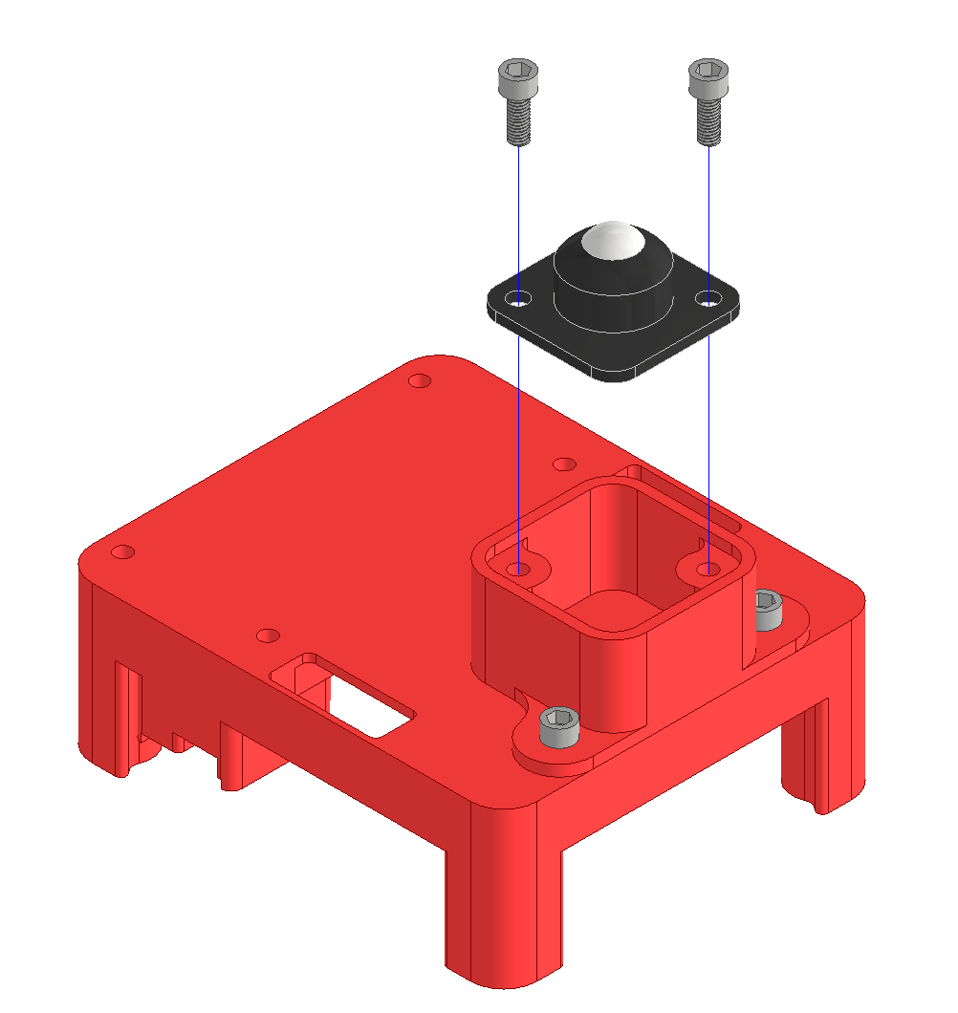
2 x C
A
B
 | Micromouse Starter Robot | Step: | 3
Parts Required:
- 1 x MM Base Plate with components fitted (where steps 1 to 2 of this procedure have been completed)
- 2 x MM Motor Clamp
- 2 x Micro Motor 60RPM
- 4 x M3x8mm Hex Socket Bolt

Instructions:
- Place the Micro Motors (C) on the MM Base Plate (A) and secure using MM Motor Clamps (B).
- Fasten the MM Motor Clamps (B) to the MM Base Plate (A) using M3x8mm bolts (D).
- Route the cables from the Micro Motors (C) through the designated holes in the MM Base Plate (A).
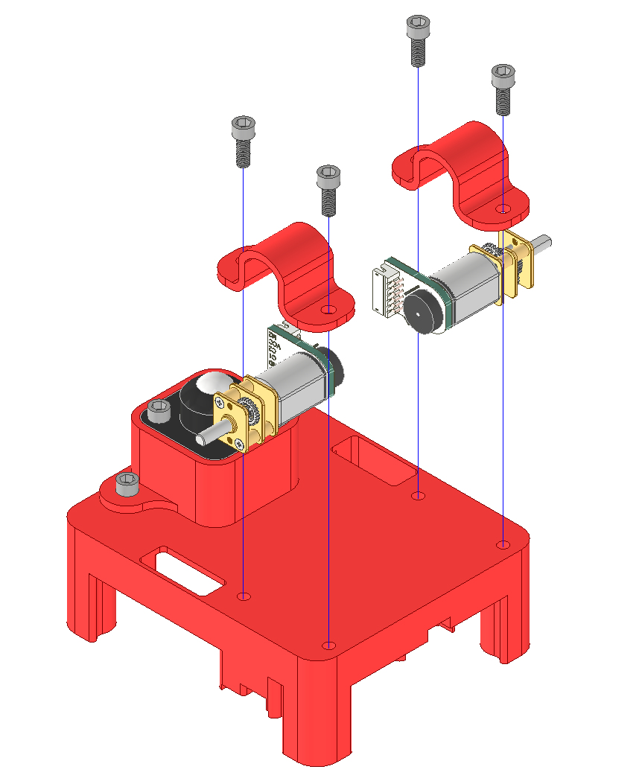
2 x B
4 x D
2 x C
A
 | Micromouse Starter Robot | Step: | 4
Parts Required:
- 1 x MM Base Plate with components fitted (where steps 1 to 3 of this procedure have been completed)
- 3 x IR Sensor
- 3 x M3x8mm Hex Socket Bolt

Instructions:
- Fasten the IR Sensors (B) to the MM Base Plate (A) using M3x8mm bolts (C).
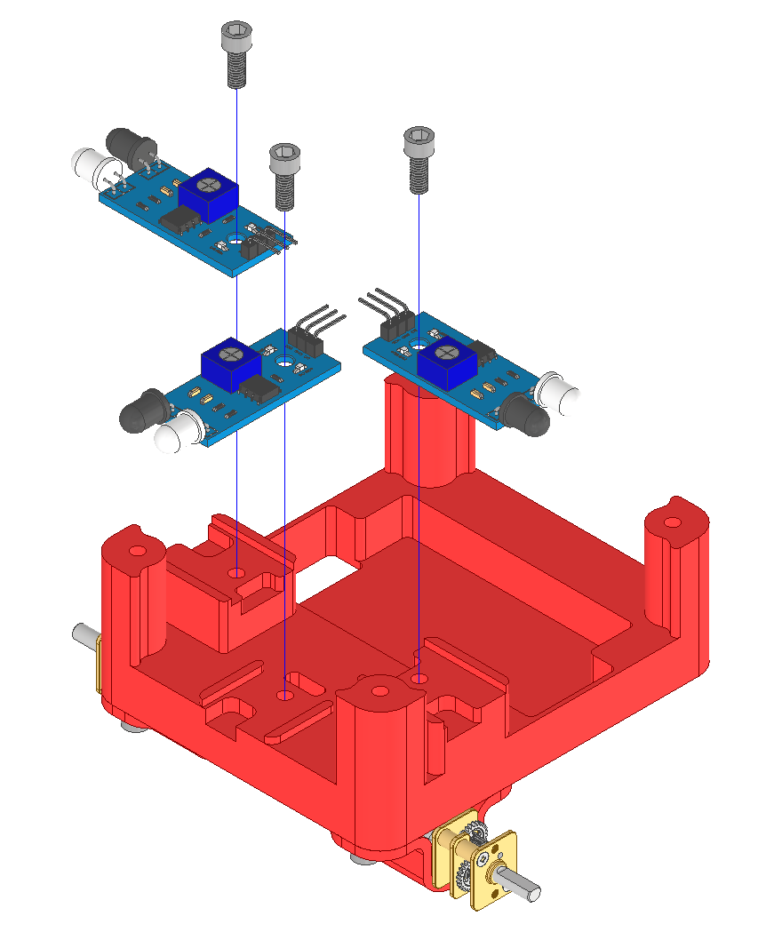
3 x B
3 x C
A
 | Micromouse Starter Robot | Step: | 5
Parts Required:
- 1 x MM Base Plate with components fitted (where steps 1 to 4 of this procedure have been completed)
- 1 x 3.7B LiPo Battery

Instructions:
- Place the LiPo Battery (B) in the designated cutout in the MM Base Plate (A).
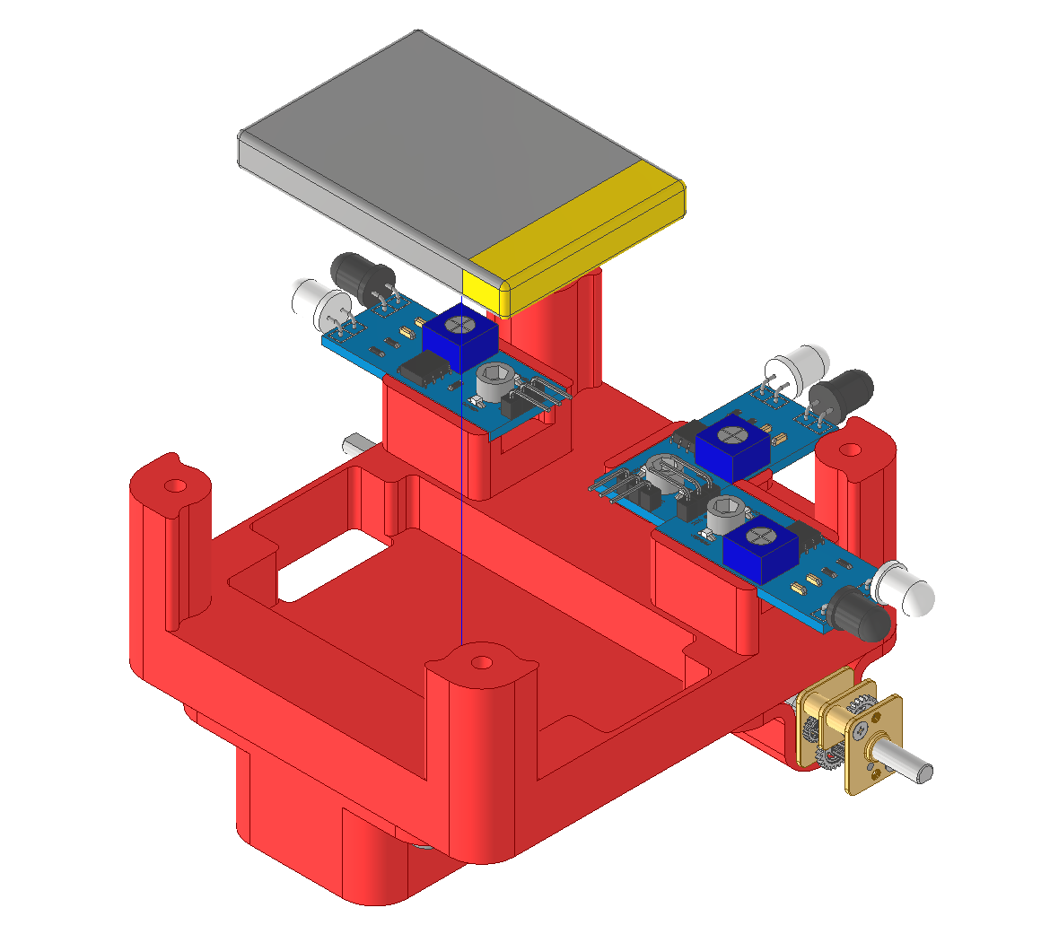
B
A
 | Micromouse Starter Robot | Step: | 6
Parts Required:
- 1 x MM Base Plate with components fitted (where steps 1 to 5 of this procedure have been completed)
- 1 x MM Top Plate
- 1 x MM PCB
- 4 x M3x8mm Hex Socket Bolt

Instructions:
- Place the MM Top Plate (B) on the MM Base Plate (A).
- Rotate the MM PCB (C) to the desired orientation, place on the MM Top Plate (B) and fasten using M3x8mm bolts (D).
- Route the motor cables, battery cable, and IR sensor cables through the designated holes in the MM Top Plate (B) and connect accordingly to the MM PCB (C).
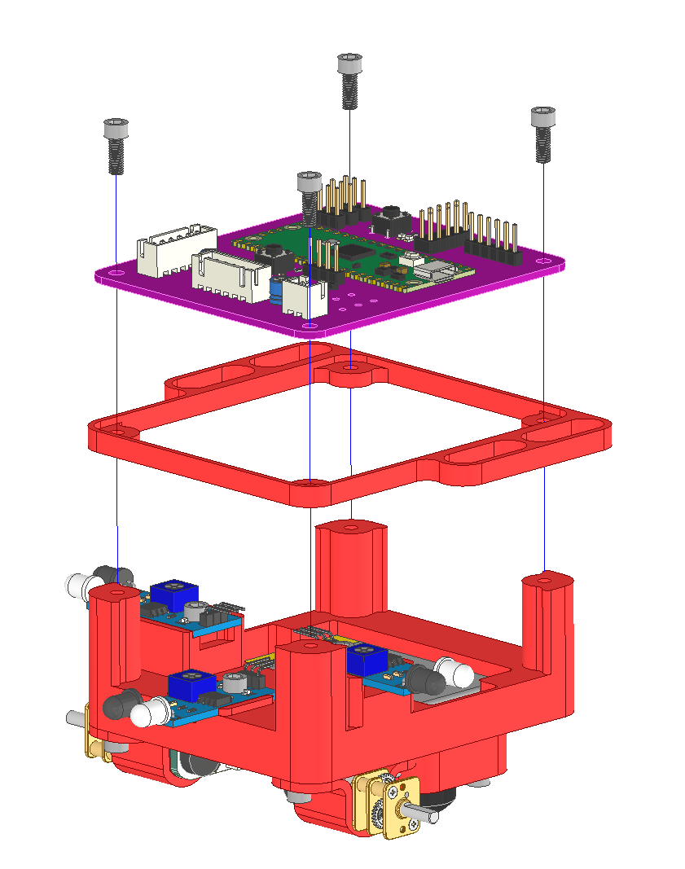
A
4 x D
B
C
 | Micromouse Starter Robot | Step: | 7
Parts Required:
- 1 x MM Base Plate with components fitted (where steps 1 to 6 of this procedure have been completed)
- 2 x 43mm Rubber Wheel

Instructions:
- Connect the 43mm Rubber Wheels (B) onto the motor shafts on the MM Base Plate (A) until flush.
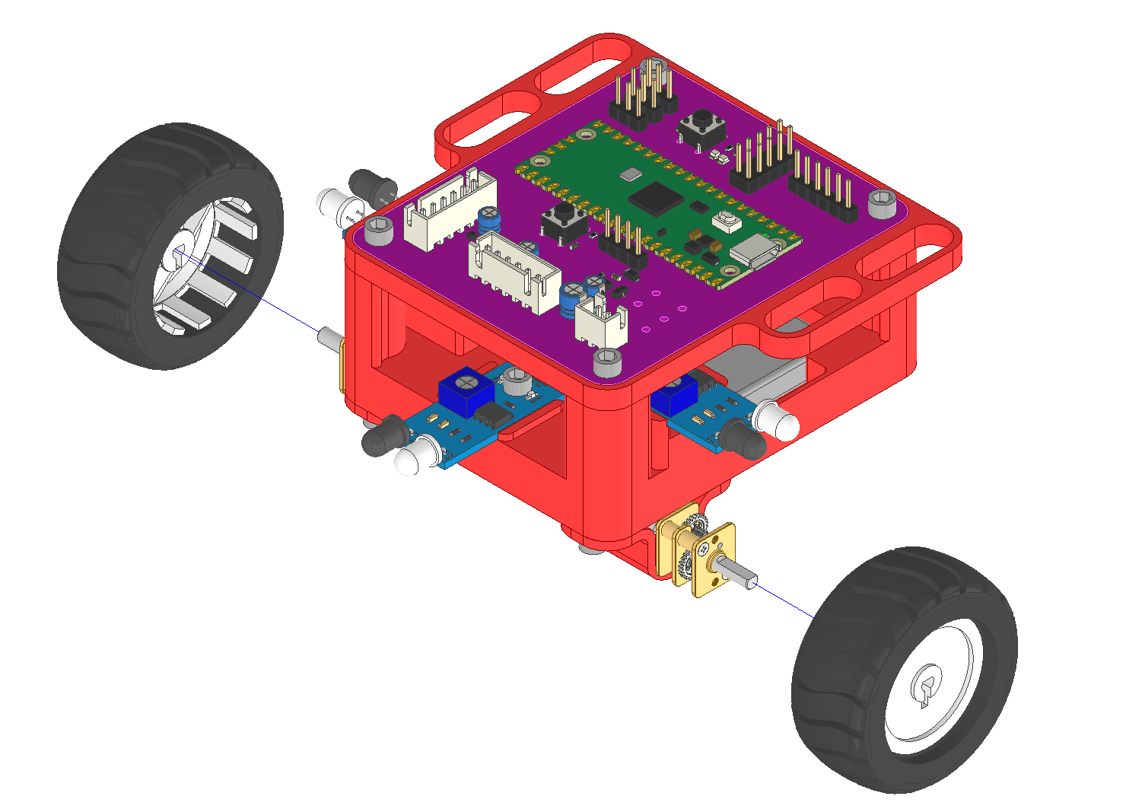
A
2 x B
 | Micromouse Starter Robot | Step: | 8
Parts Required:

Instructions:
- Assembly Complete.
